1. **VUser**: This is purely performance Testing Term.
2. To create load like 10000 concurrent users for an app at the same point of time is impossible for performance testing.   
   That is why we create virtual users which are called VUsers.  
   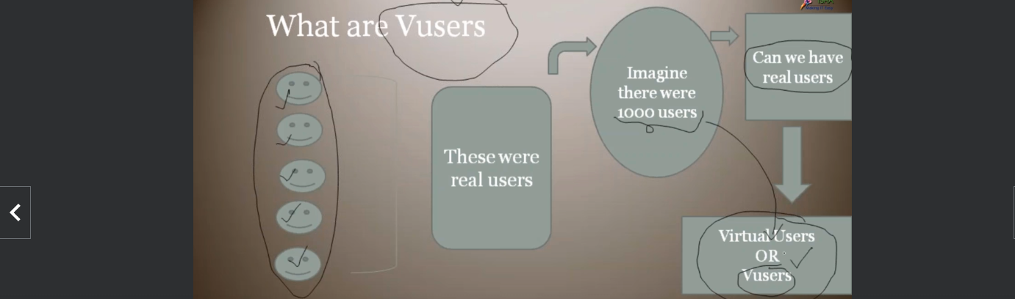
3. **VUsers**:
   1. Virtual Generated Users.
   2. There is a machine called **LG (Load Generator) Machine.  
      This term is related to LoadRunner**.  
      In JMeter, it is called **Agent Machine**.
   3. This machine can generate virtual users, but they can act like real users.
   4. This machine is part of LoadRunner.  
      This machine will be installed along with the LoadRunner in our training purpose but in the real world, it is installed remotely somewhere on a machine.





1. 